Name Date
Progress test 3
Listening
Part 1
There are five questions in this part.
For each question there are three pictures and a short recording.
For each question tick the best answer, A, B or C.

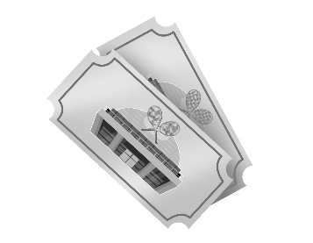
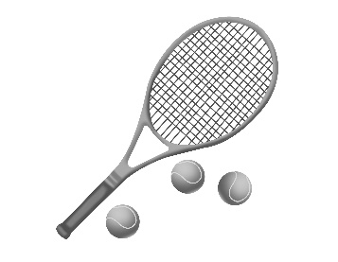

1 What did the girl win in the school tennis tournament?
<AW_PT3a>

A |  |  |  | B |  |  |  | C

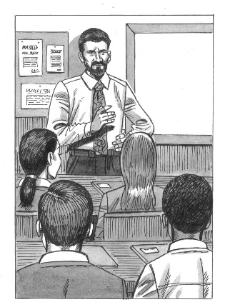
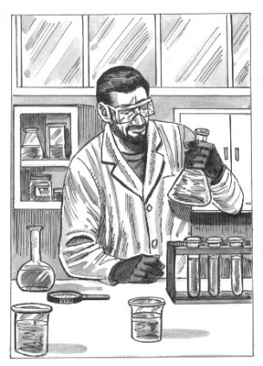
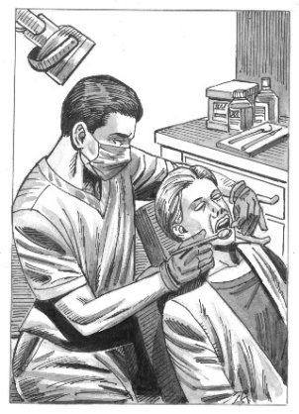
2 What job would the boy like to do in the future?

A |  |  |  | B |  |  |  | C

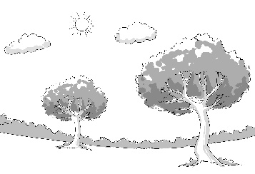
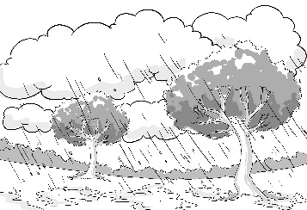
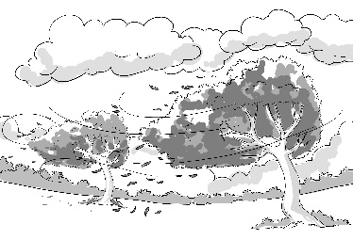
3 What was the weather like yesterday?

A |  |  |  | B |  |  |  | C
4 What did the boy most enjoy doing on his holiday?
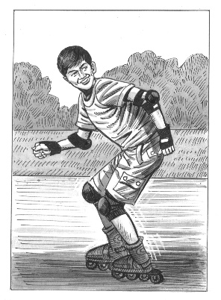
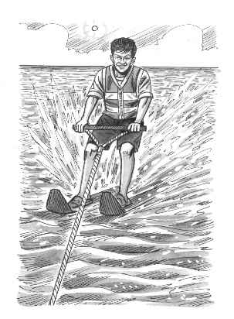
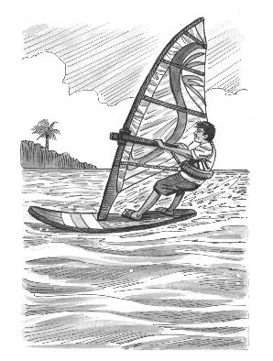

A |  |  |  | B |  |  |  | C

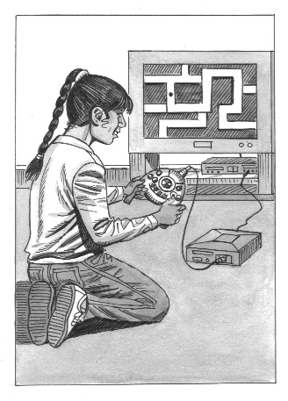
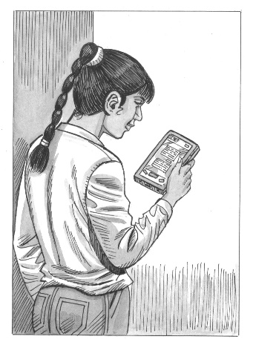
5 What have the girl’s parents made a new rule about?
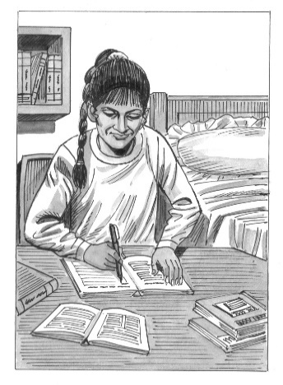

A |  |  |  | B |  |  |  | C

[Total: 5 marks]

Part 2
You will hear people talking in five different situations.
Circle the best answer, A, B or C.

6 You hear a girl telling a friend about her stay at an eco-hotel.
What surprised her about it?
A how much air conditioning it had
B some of the food it served
C the souvenirs it sold

7 You hear two classmates talking about a science class.
Why did the girl get told off in the class?
A She distracted other students.
B She interrupted the teacher.
C She arrived late.

8 You hear two friends talking about zoos.
What do they agree about?
A Animals in them should be released.
B Animals should not be kept in cages.
C Animals should only be used for breeding.

9 You hear a boy leaving a message for a friend about vlogging.
Why does the boy want to start vlogging?
A to develop his technical skills
B to create a good impression with friends
C to gain experience for a future career

10 You hear two friends talking about a music competition they have both entered.
How does the girl feel about it?
A excited about performing on stage
B confused about the competition rules
C worried about the other competitors
[Total: 5 marks]
Part 3
You will hear a student called Sanjay giving a talk to his class about helping a tree planting charity.
Complete the sentences with a word or short phrase.

Tree planting charity

Sanjay heard about the tree planting charity from his (11)…………………………… .

The first time Sanjay planted trees, his (12)…………………………… hurt afterwards.

Sanjay recently helped plant trees near a (13)………………………… .

Sanjay says he feels (14)…………………………… when he’s outdoors planting trees.

For more information about the charity, visit (15) www. …………………………… .net.

[Total: 5 marks]

Part 4
You will hear an interview with a girl called Anisha, talking about her favourite sport, taekwondo.
Circle the best answer, A, B or C.

16 Anisha first heard about taekwondo
A at a school event.
B on a TV programme.
C at a local competition.

17 How did Anisha feel during her first session at the taekwondo club?
A apprehensive about hurting someone
B confused about what to do
C delighted by her ability

18 What mistake did Anisha make during her first taekwondo competition?
A She didn’t concentrate enough.
B She didn’t follow her coach’s advice.
C She didn’t trust her own ability.

19 What personal quality does Anisha say it’s most important to have in taekwondo?
A patience
B strength
C self-esteem

20 In the future, Anisha says she’d like to
A teach others how to do taekwondo.
B enter taekwondo competitions abroad.
C become a taekwondo professional.

[Total: 5 marks]

Part 5
You will hear five teenagers talking about jobs they might do in the future.
Choose from the list A–H what each speaker says about the job they might do in the future.
Write the correct letter in the box next to each speaker.
There are three extra letters that you do not need to use.

A | I’ll probably change my mind about my future career.
B | I know it’s a difficult profession to enter. |  | 21 | Speaker 1
C | I need to get more advice about my career goals. |  | 22 | Speaker 2
D | I don’t know much about what the job involves. |  | 23 | Speaker 3
E | I’m worried about how much studying is involved. |  | 24 | Speaker 4
F | My family agree with my career choice. |  | 25 | Speaker 5
G | It’s the only job I’ve ever wanted to do.
H | I know someone who does the job already.
[Total: 5 marks]

Reading and Use of English
Part 1
For each question, choose the correct answer, A, B, C or D.
Example:
0 A built B raised C grown D gained

The advantages and disadvantages of tourism
……….
Tourism has (0) a lot in recent years in many places, which has both advantages and disadvantages. The main (1) is the money it brings to a region. Tourists spend lots on the (2) they stay in, such as hotels, and on food in shops and restaurants. They also buy locally made items and (3) to remind them of their holiday. All of this helps the local (4) . In popular tourist regions, (5) may be made to the facilities there, such as the (6) system, which local people can also use.
……….
……….
………..
………..
………..
………..
………..
………..
(7) , there are also disadvantages. Firstly, tourist destinations may become extremely (8) , making it difficult for local people to move around and enjoy the facilities in their own area. The price of houses and food may also increase, making it expensive to live there.
1 A use B value C help D benefit
2 A accommodation B housing C rooms D space
3 A rewards B souvenirs C presents D prizes
4 A market B produce C economy D success
5 A increases B improvements C rises D maximums
6 A transport B travel C tour D journey
7 A Unless B Although C Since D However
8 A traditional B historic C crowded D calm

[Total: 8 marks]

Part 2
Look at the text in each question. What does it say?
Circle the correct letter, A, B or C.
Example:
0 |   PE Kit  School PE kit (white short-sleeved shirt, dark blue tracksuit bottoms) must be worn in the gym. Remember that other colours of shirts and tracksuit bottoms are unacceptable. | - The school rules regarding PE kit have recently changed.  - Students all have to wear similar clothes for PE lessons.  C A range of comfortable clothing can be worn in PE lessons.
9 | From: Mr Lee  To: Science homework  The homework I gave you yesterday on genetics will take longer than I thought. I can give you until Friday of next week instead of Monday. | A Mr Lee wants to know why students haven’t handed in yesterday’s homework yet.  B Mr Lee has allowed students extra time to complete their genetics homework.  C Mr Lee has changed the day students can see him to discuss their homework.
10 | Glass only. Use the green bin for metal recycling and the yellow for plastics. | A A range of materials can be put into this bin for recycling.  B Glass cannot be recycled in any of the coloured bins.  C Old food cans should be put into the  green bin.
11 |   Hasan,  I’m having a great time. I’ve been on a few day trips – the sightseeing tours weren’t as much fun as the theme park. Continuing my windsurfing course tomorrow.  Adnan  Aruna | A Adnan is looking forward to going on some day trips.  B Adnan preferred sightseeing to going to the theme park.  C Adnan has already started learning how to windsurf.
12 | Aisha  I started at a new drama club today. The students are really respectful and the teachers are so enthusiastic. Do you want to come to the next one?  Magda | A Magda thinks the drama club was a positive experience so is suggesting Aisha attends.  B Magda is describing what she did at her new drama club to Aisha.  C Magda wants to change drama clubs and is asking if Aisha knows a good one.
13 |   Stressed about schoolwork or miserable about life generally?  Then why not contact student services for a chat with someone who’s trained to listen and help?  Appointments daily  during school hours. | A Students can get help with their homework if they don’t understand it.  B Students can discuss their emotions and problems so that they feel better.  C Students can join daily support groups to help each other with difficulties.

[Total: 5 marks]

Part 3
Complete the conversation between two friends.
What does Demir say to Aydin?
Write the correct letter, A–H, from the answers.
Example:
Aydin: What do you use your phone for most, Demir?
………
Demir: 0 H

Aydin: Yes, me too. I get really annoyed with friends who fill their posts with emojis.
Demir: 14 …………
Aydin: I suppose it can be. I don’t take many photos on my phone.
Demir: 15 …………
Aydin: Really? But you can look in the mirror if you want to know what you look like!
Demir: 16 …………
Aydin: Oh, OK. I’d like to try vlogging one day.
Demir: 17 …………
Aydin: The different games I play online, I suppose.
Demir: 18 …………
Aydin: I know – I hope I will too.

A Really? About what?
B But using them is quicker than explaining how you feel.
C I don’t really know what that is.
D True, but I take them to remember things I’ve done, not my appearance.
E What could you see in the pictures?
F I don’t either – just a few selfies.
G Good idea! Some people make lots of money doing that.
H Checking social media, I guess.
[Total: 5 marks]
Part 4
For each question, write the correct answer.
Write one word for each gap.

School rules
……………
In my blog today, I’m going (0) to write about our school rules. (19)………… rule that affects students most is that we (20)………… not allowed mobile phones in class. We have to give them to the teacher (21)………… switch them off and put them in our bags. I agree (22)………… this rule. (23)………… we didn’t have it, then students would spend lessons looking (24)………… their phones. At my school, students have to wear a uniform from the age of 11 (25)………… they are 16. After that, they can wear casual clothes. I don’t like this rule and think it should change. What (26)………… you think? Write a comment below and tell me.
[Total: 8 marks]

Part 5
You are going to read four teenagers describing what they do to help the environment.
Choose from the sections A–D to answer the questions on the next page. The sections may be chosen more than once.

What I do to help the environment

A Ahmed
It’s important to make helping the environment fun. I actually use some of the metal and plastic we’d otherwise throw away to make sculptures, so try thinking carefully about what you can reuse rubbish for. I do all the usual things too, like using less electricity by switching stuff off when I’m not using it. I got into all of this after seeing a documentary on TV that showed the damage people were doing to our beautiful planet – it was frightening! My family and I really need to use less water, so researching how to do that is my next plan.

B Isabella
I do lots of small, simple things to help the environment, like turning the tap off when I’m brushing my teeth and having shorter showers, or switching off lights when no one’s in the room. I can’t understand why people harm the environment on purpose, like when they throw sweet wrappers and other stuff on the ground instead of putting them in the bin. It makes me furious, because it’s so easy to avoid. Perhaps one day behaviour like that will be treated as seriously as other crimes, and everyone will stop damaging the Earth as a result.

C Ding
I’ve recently started working as a volunteer for an organisation that cleans up litter and other rubbish from rivers and other areas of water. All their money comes from donations, so they need people like me to help them. Since I started doing it, both of my parents and my sister have also joined because of the good things I told them we were doing. It’s hard work, so is really good exercise – I think it’s better than running for keeping fit. I’ve also started checking the labels on products I buy, to see where they have come from. Buying local is always best.

D Irinya
I’m always looking for ways to help the environment, mainly at home but also when I’m shopping with my mum or dad. There’s lots of litter near to where I live, so one of the things I do is to take a bag with me and pick some of it up when I’m out jogging. It’s even got a special name – plogging! I use a lot of electronic gadgets and they all need recharging. My parents explained that producing the power needed to do this harms the environment, so I don’t use them as much as I used to.

In which section does the writer:
27 describe how they feel when they see litter? ……….…
28 say how they became interested in helping the environment? ……….…
29 explain why they use less electricity than before? ……….…
30 mention an environmental charity they belong to? ……….…
31 describe a hope they have for the future of the planet? ……….…
32 describe what they do to save water? ……….…
33 say how their actions have influenced their family? ……….…
34 make a suggestion about recycling? ……….…
35 mention a sporting activity that helps the environment? ……….…
36 give advice about shopping in an environmentally friendly way? ……….…
[Total: 10 marks]

Part 6
You are going to read an article about a girl describing her life on a farm.
Read the questions on the next page.
For each question, choose the correct answer, A, B, C or D.

My life on a farm
By 14-year-old Maisie Johnson

I live on a farm with my parents and two older brothers. Everyone helps out and that means getting up early. It’s been part of my routine for as long as I can remember, so it just feels normal now. There’s never enough time to sit and have toast and cereal, as there’s too much to do. In fact, the rest of the day feels relaxed compared to mornings on the farm. In summer, the sun’s already up so it’s lovely to be outside, but it’s harder in winter because it’s still dark.
There’s lots to do because we have cattle, sheep and chickens on the farm, as well as growing fruit and vegetables and making a range of food. Mixing the fruit into the milk for the yoghurt is top of my list of enjoyable jobs. Collecting the apples is probably the hardest thing I do. My brothers are responsible for making sure the animals have enough to eat, while I get the eggs from the henhouse.
The whole family thinks of new ideas for the farm. My parents say no to most of mine because they know they won’t work, which is fine. Allowing people to camp on one of our fields is one example. Showing people around the farm for a small fee was another – we’re just too busy! We’ve made our own cheese for years, but I wondered if creating ice cream using milk and fruit from the farm would work. Mum and Dad thought it was my best suggestion yet.
I sometimes see my schoolfriends at their homes, but they love the farm so come here more often. They aren’t usually allowed to go any further than their local park, so they really wish they had a whole huge farm to explore and enjoy. When I tell them I have to work more than I play, they just say it would be worth it. It’s funny how nervous they are of the cattle and sheep – they’re just not used to being so close to them.

37 What does Maisie say about having to get up early in the morning?
A It’s the busiest part of the day for her.
B She’s never really got used to it.
C She enjoys having a big breakfast.
D It’s nice watching the sun come up.

38 Which job does Maisie enjoy most on the farm?
A picking the fruit
B collecting the eggs
C feeding the animals
D making a dairy product

39 Which of Maisie’s ideas for the farm did her parents particularly like?
A using a field as a campsite
B making their own cheese
C producing ice cream
D giving guided tours

40 What do Maisie’s schoolfriends think about her life on the farm?
A They think she has to work too hard.
B They wish she lived nearer to them.
C They are a bit jealous of her freedom.
D They love spending time with the animals.

41 What would Maisie’s parents say about her?
A Maisie seems to spend more of her free time at her friends’ houses than she does here.
B Maisie has helped on the farm since she was a little girl and does jobs all year round.
C Maisie and her brothers can never seem to decide what jobs they’re going to do each day.
D Maisie gets very upset when we say no to some of the ideas that she has for the farm.

42 What is Maisie doing in this text?
A explaining what it’s like to live on a farm
B describing how her family farm has changed
C encouraging people to think about farming as a career
D recommending farms as interesting places to visit
[Total: 6 marks]

